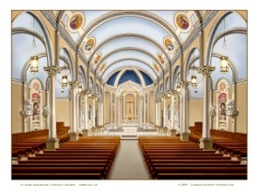
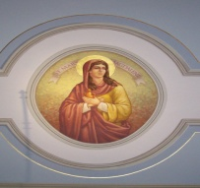
Confidential Census Form for St. Mary Magdalen Catholic Church
300 Pere Megret St., Abbeville, LA 70510 (337) 893-0244
Please complete & return to the Administration office or place in collection basket.
Date ______________ New Info__________________ Update ______________________

Husband Last Name | Husband First Name |  | Religion | Husband Birth Date |  | ___Married  ___Single  ___Widowed  ___Divorced  ___Other | Were You Married by a Catholic Priest or Deacon? ______Yes _____ No
Husband Last Name |  |  | Religion | Occupation |  | ___Married  ___Single  ___Widowed  ___Divorced  ___Other | If No, would you be interested in discussing this? _____Yes ____No
Wife Last Name | Wife First Name |  | Religion | Wife Birth Date |  | ___Married  ___Single  ___Widowed  ___Divorced  ___Other | Place & Date of Marriage
Wife Last Name |  |  | Religion | Occupation |  | ___Married  ___Single  ___Widowed  ___Divorced  ___Other | Ethnic Group – Please circle  1-African American 2-Asian 3-Caucasian  4- Hispanic 5-Native American 6- Other _________
Wife Last Name | Maiden Name
Address |  |  |  |  | City | State | Zip
Phone (Home) |  | Phone (Work)  His  Hers |  |  | Phone (Cell)  His  Hers | E Mail Addresses  His  Hers

(Please use back of page for additional children) ** Please ✓check which sacraments children have received

Children - Full Name  (Still Living with You) | Sex M/F | Birth Date | Grade & School Attending |  | Baptism | First  Communion |  | First  Penance | Confirmation
How long have you been attending St. Mary Magdalen Church? | Do you wish to receive Church Support envelopes?  ____ Yes ___No |  |  | Do you wish to be involved in a parish ministry?  Interests: |  |  | Questions/ Comments: Please use back of page for more comments.

